**SKILLS**

+91 6382824329

tamilhacker550@gmail.com

cyberspark550@gmail.com

95/3 vasantha nagar,

Lalgudi-trichy 621601

**Contact Us**

ABOUT ME

**2023**

**2019**

**2017**

EDUCATION

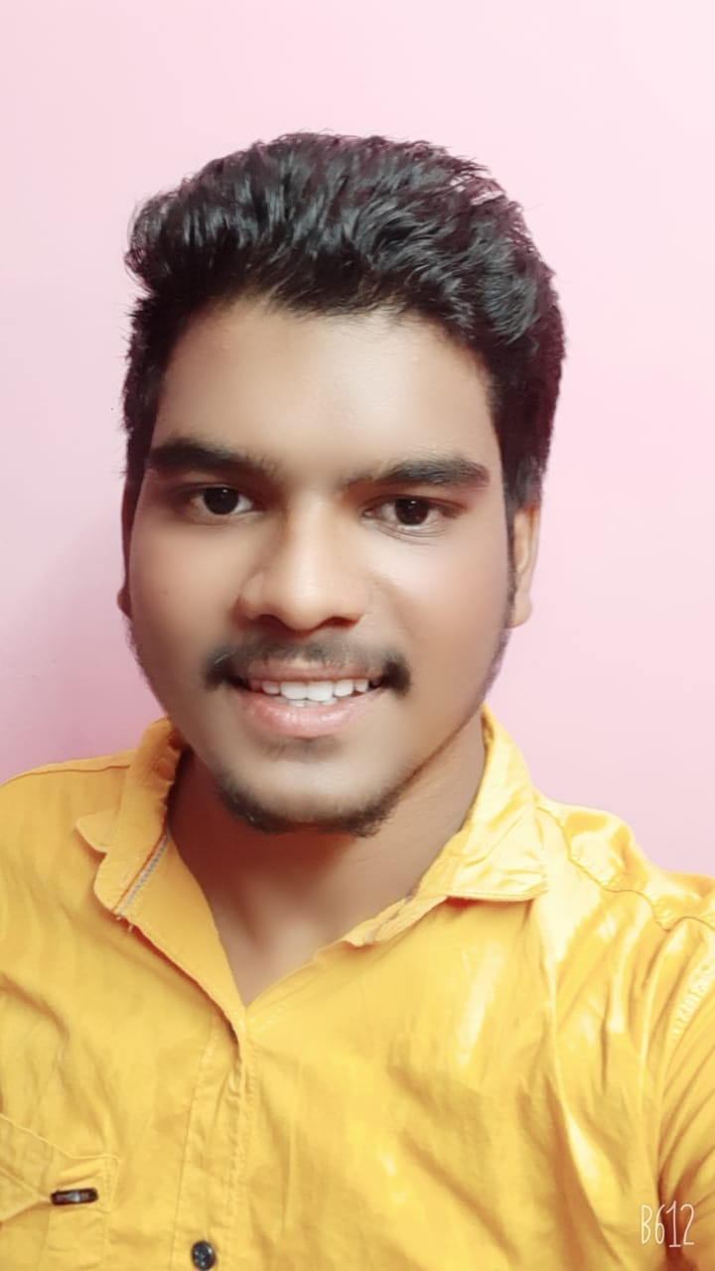

**PRASANNA**

**KUMAR**

CYBERSECURITY RESEARCHER&DEVELOPER

* 21y/o Studying Computer Science & Engineering at MIET Engineering College
* Playing CTFs for tryhackme.
* Busy in penetration testing
* 4 Years learning Experience in cyber security

B.E Computer Science

M.I.E.T ENGINEERING COLLEGE

12th standard

Nest matriculation higher secondary school

10TH Standard

Nest matriculation higher secondary school

Web app penetration testing (9/10)

Networking (9/10)

Android app penetration test(6/10)

Malware analytics (5/10)

Binary exploitation (7/10)

Cyber forensics (7/10)

**Interests & Hobbies**

* Blogging
* Reading
* Travelling
* CTF playing

Developing skill

* HTML
* CSS
* JAVASCRIPT
* BOOSTRAP
* PYTHON
* REACT JS

**PORTFOLIO**

https://0xprasanna-portfolio.netlify.app/

https://0xprasanna.github.io/portfolio/

* EXPRESS JS
* NODE JS
* MONGODB
* BASH
* GIT
* DOCKER

HTML  
CSS  
JAVASCRIPT  
BOOSTRAP  
NODEJS  
C#

ELECTRON JS